Simulation of Forward Curves and Spot Prices
Hannah Jabri
August 1, 2006

Forward Curve
The FEA adopts a multi-factor model to describe the evolution of the forward curve. The assumption is that forward prices with different maturities are driven by different stochastic processes. These latter processes are often referred to as the volatilities functions since they constitute the covariance matrix of the forward curve. The forward price evolution is given by the following process:
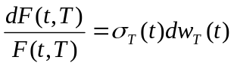 (Eq. 1)
where F(t, T) denotes the price at time “t” of a futures contract with maturity “T”, 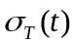 the volatility of F(t, T) and 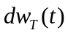 a Brownian motion.
We adopt a Principal Component Analysis (PCA) to estimate the covariance matrix, and therefore the volatilities functions of the forward curve. Each volatility function could be viewed as a risk factor, which tends to “shift”, “tilt”, or “bend” the forward curve. The first factor is either positive or negative for all maturities, implying that a shock to the system affects the forward curve in the same manner. The “tilting” factor causes the short and long term maturities to react differently. The third most important factor is the “bending factor” which causes the middle section of the forward curve to react to the opposite movements of short and long term maturities. Three factors do not always suffice to describe the variation of the covariance matrix. It is necessary to look at its eigenvalues and their contribution to the variability of the forward curve.
For a given set of futures contracts, (e.g. Aug06 till Jan07), we estimate the covariance matrix of their historical log-returns. PCA requires the estimation of the eigenvalues and eigenvectors of the covariance matrix. Rewriting (Eq. 1) gives,
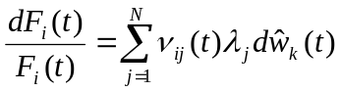 (Eq. 2) where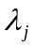 is the squared root of the j^{th} risk factor, 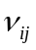 is its corresponding eigenvector and 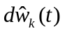are independent Brownian motions. Also for simplicity, we replaced “T” by “i” =1…N, which denotes the delivery month.
Upon examining the eigenvalues, one can determine the number of factors, n << N, required to explain a certain level of variation of the forward curve, say 96%. It should be added that each eigenvalue is the variance of its corresponding principal component. Therefore, the variation explained by the first 3 factors is the sum of the first three eigenvalues divided by the total sum of all eigenvalues.
Applying Ito’s lemma to (Eq. 2) with n factors gives:
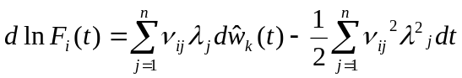 (Eq. 3)
The simulation of the forward curve is based on the discretized solution of (Eq. 3).
Additionally, we provide seasonal PCA eigenvalues and eigenvectors according to the seasons of the simulated pricing dates. For more details, please refer to the R file “FC.PCA.Fncs.r“, which simulates the forward curves based on seasonal PCA. For a concrete example, please see “FC.PCA.example.r”. Both files are found in the directory “S:\Risk\Temporary\PCA”

Simulation of Spot Prices
To model spot prices, the FEA postulates that they mean-revert to their corresponding prompt-month futures contract, F_{t}:
(Eq. 4) where “a” is the spot mean-reverting rate; “” the spot-to-prompt month correlation, “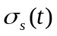” the volatility of the spot price at time t; and finally 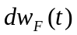 and 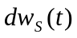are independent Brownian motions for prompt-month futures and spot prices, respectively.

Parameters Estimation
- Estimation of the spot mean-reversion rate
We estimate the mean-reversion rate “a” by regressing 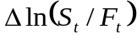 on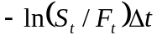, using historical spot and prompt-month prices.

- Estimation of “”, the correlation coefficient
From the fitted linear model used to estimate “a”, we then compute the residuals as the difference between the values of the response variable and fitted values, 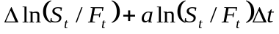.
Next, we calculate Pearson’s linear correlation coefficient between the residuals and the prompt-month log returns, 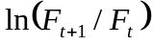. The spot-to-prompt month correlation for a given month, January for instance, is taken to be the average of all January spot-to-prompt months’ correlations in our historical dataset.

- Estimation of the spot volatility at time t.
The spot volatility is calculated on a monthly basis. In other words, we first aggregate the daily spot log-returns by month and year (e.g. Jan03, Feb03… July06). Jan06 volatility is estimated as the standard deviation of Jan06 daily log-returns. Finally, the volatility of January is taken to be the average of all January volatilities in our historical dataset.

- Spot Simulation
Thus far, we have estimates for the spot mean-reversion rate, monthly spot-to-prompt month correlations, and monthly historical spot volatilities. We simulate spot prices from the discretized version of Eq. 4:
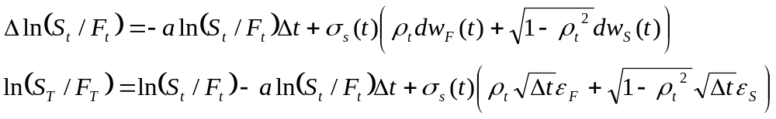
where 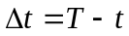 ,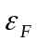 and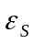 are two independent standard Gaussian variables for prompt-month futures contracts and spot prices, respectively.
Letting 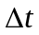be 1 day and the volatility being daily,
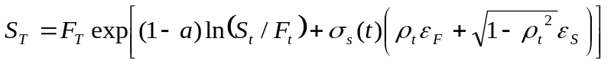 (Eq. 5)
This final expression of S_{T} is not an exact solution and is subject to discretization error. Furthermore, the simulated spot prices are meaningless; in our dataset, they oscillate between 0 and Infinity.
We replaced 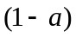 in (Eq. 5) by 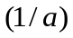. The resulting expression for S_{T} is given by:
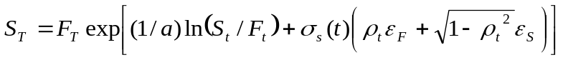 (Eq. 6)
It is true that this change has no mathematical justification; however, the simulated paths are striking. The average of all simulated spot prices for a given month is extremely close to the prompt-month futures contracts prices. The figure below illustrates few simulated paths.
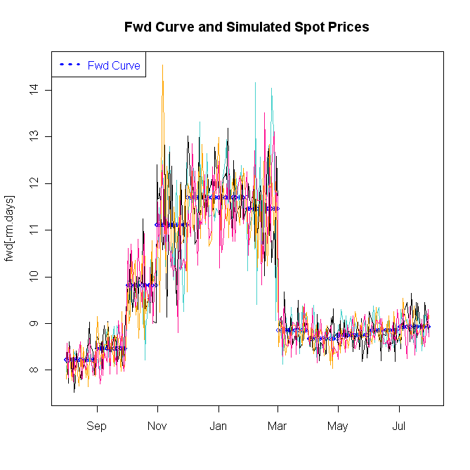
The key inputs to the spot simulation are the monthly volatilities (user-specified), which cause the most volatile months to spike.
For further details on the estimation of the parameters of (Eq. 4) and the spot prices simulation, please refer to the R file “FEA.spot.prompt.analysis.r” which is found in the directory: “S:\Risk\Temporary\Spot Simulation”.

We have also implemented a simpler model than the FEA’s to simulate spot prices based on a current forward curve. This second modeling approach postulates that spot prices follow a geometric Brownian motion:
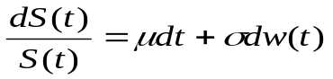
Using Ito’s lemma, we have (Eq. 7)
To be consistent with the forward prices observed in the market, we take 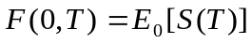. This implies
Therefore, given forward prices with different delivery dates F(0,1),…F(0,N), we can simulate using:
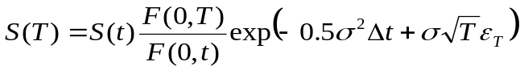 (Eq. 8)
The spot prices simulated from (Eq. 8) do not follow the evolution of the forward curve.
The following plot shows few simulated paths from (Eq. 8).
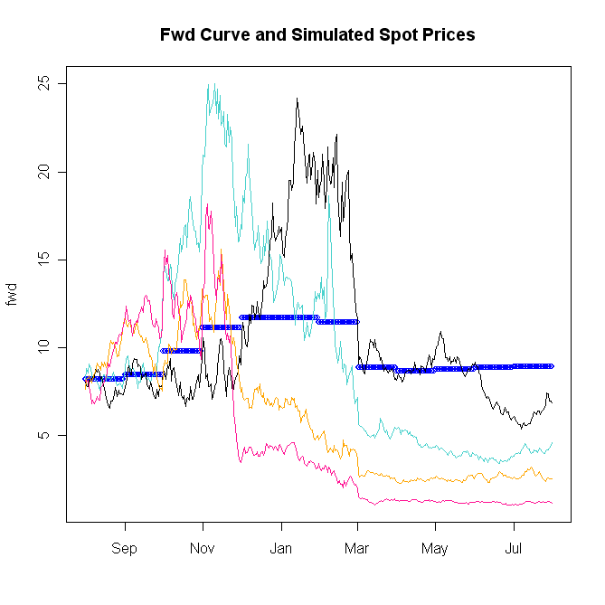

FEA User Guide, Technical Reference, page 62.
FEA User Guide, Technical Reference, page 63.
The estimation of the spot mean-reversion rate and spot-to-prompt-month correlations are based on Josh Gray VBA model.

